

Student Performance Monitoring System

CSE303

Database Management systems

| **ID** | **NAME** |
| --- | --- |
| 1830221 | Md.Abubakkar Siddik |
| 1921662 | Adnan Rahman Sharon |
| 1831110 | Md.Ashikur Rahman |
| 1831003 | Saif Islam Anik |
| 1921430 | Shahadatul Islam |

# 

# 

Table of Contents

# 

**CHAPTER 1 : INTRODUCTION** **3**

SECTION 1.1: BACKGROUND OF THE PROJECT 3

SECTION 1.2 : OBJECTIVES OF THE PROJECT 3

SECTION 1.3 : SCOPE OF THE PROJECT 3

**CHAPTER 2: REQUIREMENT ANALYSIS** **4**

SECTION 2.1: DESCRIPTION OF THE CURRENT SYSTEM: 4

SECTION 2.2 : DESCRIPTION OF THE PROPOSED SYSTEM: 5

SECTION 2.3 : AS IS RICH PICTURE 6

SECTION 2.4 : AS IS SIX ELEMENTS ANALYSIS (AS IS) 7

SECTION 2.5 : AS IS PROCESS DIAGRAM 15

SECTION 2.6 :AS IS PROBLEM ANALYSIS 17

SECTION 2.7 : TO BE RICH PICTURE 20

SECTION 2.8 : TO BE SIX ELEMENTS ANALYSIS 21

SECTION 2.9 : TO BE PROCESS DIAGRAM 29

**CHAPTER 3: LOGICAL SYSTEM DESIGN** **32**

SECTION 3.1 : BUSINESS RULE 32

SECTION 3.2 : ENTITY RELATIONSHIP DIAGRAM (ERD) 33

SECTION 3.3: RELATIONAL SCHEMA 34

SECTION 3.3:NORMALIZATION 35

SECTION 3.4:DATA DICTIONARY 39

**CHAPTER 4: PHYSICAL SYSTEM DESIGN** **47**

SECTION 4.1: INPUT FORMS 47

SECTION 4.2: OUTPUT REPORT 53

**CHAPTER 5: CONCLUSION** **57**

SECTION 5.1:PROBLEM & SOLUTION 57

SECTION 5.2: FEATURES & FUTURE DEVELOPMENT 58

SECTION 5.3: CONCLUSION & RECOMMENDATION 58

**Contribution of Each Member** **59**

# 

# **CHAPTER 1 : INTRODUCTION**

## **SECTION 1.1: BACKGROUND OF THE PROJECT**

The Student Performance Monitoring System focuses on performance monitoring of student’s continuous assessment (tests) and examination scores in order to predict their final achievement status upon graduationThe project is to build a software system which can effectively evaluate and assess the students. The system takes in the newly introduced assessment technique which uses Course Outcomes (COs) and Program Learning Outcomes (PLOs). PLOs represent a specific skill set the student should gain or expected to gain by the end of the course. The main idea is to evaluate the COs achieved and mapped PLOs achieved by each student in each of the enrolled courses as that would be necessary for monitoring the student performance.

## 

## **SECTION 1.2 : OBJECTIVES OF THE PROJECT**

The Aim is to improve the current system with our proposed solution, The following tasks are :

* Create a system which takes user input with an interface.
* User Account
* Make the system accessible by permission holders.
* MAP COs with the PLOs
* Data assembling
* Data storing.
* Generating the reports

## **SECTION 1.3 : SCOPE OF THE PROJECT**

The scope of the project is a necessary condition to ensure the success of the project. When we change the existing system, we must ensure that the proposed system is more effective than the existing system. The proposed system will include evaluating the CO performed, mapping the CO to the PLO performed, and storing them as records, all of which is done manually in the existing system. These records can also be used to generate reports for analysis. Professors, students, UGC, IEB and senior management (VC, dean, manager) can access the system. Keeping detailed records of student performance is highly inefficient, so an improved and automated student performance monitoring system is needed.This project can also be useful for UGC / IEB, and future prospects seem to apply to all OBE compliant universities.

# 

# **CHAPTER 2: REQUIREMENT ANALYSIS**

Requirements analysis is a process accustomed to determine the wants and expectations of a replacement product. It involves frequent communication with the stakeholders and clients of the merchandise to define expectations and document all the key requirements. Requirements analysis could also be a team effort that demands a combination of hardware, software, and human factors engineering expertise moreover as skills in handling people. Here are the foremost activities involve in requirement analysis:

* RICH PICTURE AS-IS
* SIX ELEMENTS AS IS
* PROCESS DIAGRAM AS-IS
* PROBLEM ANALYSIS
* RICH PICTURE TO-BE
* SIX ELEMENTS TO-BE
* PROCESS DIAGRAM TO BE

## **SECTION 2.1: DESCRIPTION OF THE CURRENT SYSTEM:**

From the current system, we can mark 4 main processes.

1. Assigning Curriculum and PLO.

2. Managing CO's OBE mark sheet.

3. Evaluate students.

4. Managing OBE mark sheet.

1. From the diagram we can observe that UGC and IEB assign curriculum and PLO to Universities' higher authorities. Then higher authorities appoint PLO to the department head. Then department head store and map the PLO in storage after a detailed discussion with faculty members.

2. After preparing PLO faculty members map PLO to CO and store it in storage.

3. In this step faculty members evaluate and examine a student by assigning assignment, quiz, mid, final based on PLO and CO.

4. After evaluating students' papers, faculty members prepare the OBE mark sheet and submit their grades in the system.

## **SECTION 2.2 : DESCRIPTION OF THE PROPOSED SYSTEM:**

In the proposed system faculty prepare and store the student performance report in the system. The higher authority, Department heads, and Students can also login into the system and they can see their desired information. The system provides all users with informative bar charts, pie charts, and tables that express the PLO

achievement of all students, PLO achievement for an individual student, PLO achievement with respect to individual courses. As well as any university being able to use this system as their system by registering in it.

## 

## 

## 

## 

## **SECTION 2.3 : AS IS RICH PICTURE**

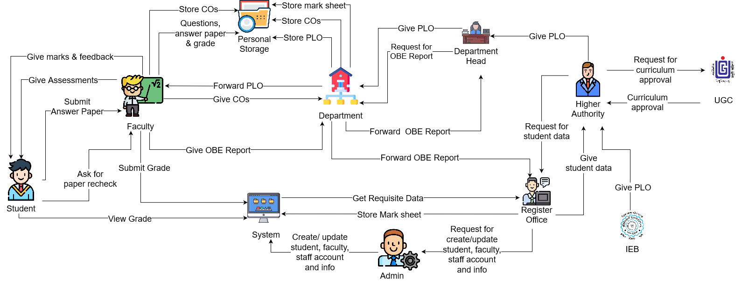 Figure 2.1: Rich Picture of Existing System to Monitor Student Performance.

## **SECTION 2.4 :** **AS IS** **SIX ELEMENTS ANALYSIS (AS IS)**

| **Process** | **System Roles** | | | | | |
| --- | --- | --- | --- | --- | --- | --- |
| **Human** | **Non Computing Hardware** | **Computing Hardware** | **Software** | **Database** | **Network & Communication** |
| Mapping PLO and CO's | **IEB**  Assign PLO to higher authority.  **Higher Authority:**  Assign PLO to department head.  **Department Head**  1. Get a PLO manual from higher authority.  2. Forward PLO manual to course Faculty and instruct them to prepare Course Outline along with assessment strategy.  3. Prepare COs  4. Map COs to Course Content.  **Faculty:**  1. Prepare Quiz,Assignment, Mid term and Final for fulfilling COs. | **Pen and**  **Paper:**  Is used for preparing initial course outline and course outcome. | **Computer**  Is used for making softcopies of PLO,COs Course Content  and Course outline.  **Printer**  Print hardcopy of PLO.COs  Course Content and Course outline. | **MS Word**  Is used for preparing course outline and course outcome. | **Department**  **Storage**  Is used for storing final copy of PLO,CO and Course outline.  **Personal Storage**  Is used for storing course content and Course outline | **Internet/Email**  Is used for sending information.  **Mobile and Telephone**  Is used for communicating information among one another. |
| Manage student & faculty and other staff account | **Registrar’s Office**  1.Request the system admin to create or update students, faculties or any staff’s account.  **Admin:**  1. Get account information from the registrar office.  2.Create a new account using the data.  3.Update any account’s information if needed. | **Pen and Paper**  1.Can be used for writing student or faculty login information( id,password and user type) for creating an account. | **Computer**  1.Use for adding/editing important information on the system.  2.For creating user accounts on the system.  3. For the request to create/edit a user's account/profile. | **System**  1.To work with student/faculty data an user interface is provided. | **Registrars’ office**  1.Students/  Faculties important info is kept as reference to the Admin for any future use.  **System database:**  1.To store,edit and receive students/  Faculties important info a system database manage service is used. | **Internet**  1.The Internet is used to use the system and store/create student/faculty accounts and data.  2.User interface and system web page is loaded using the internet. |
| Give Assessment and grading | **Faculty**  1.Take quizzes, exams, midterm, final.  2.Give assignment and project.  3.Give marks & related feedback to the student.  4.Record all the marks of every assessment.  5.Recheck the answer paper if a student asks.  6.Change marks if needed.  7. Calculate total marks of all the assessments and prepare the final grade for each of the students on each course.  8.Upload the final grade on the system.  **Student**  1.Submit an answer paper to the faculty.  2.Get marks and related feedback from the faculty.  3. Ask for an answer paper recheck if needed.  4.Login into the system.  5. View subject wise grade. | **Pen and  Paper**  1. Used to check students' answer papers.  2.Used by students for answering questions on paper. | **Computer**  1. Creating the marksheet of assessment marks.  2. Student View the marks and feedback. | **Excel Sheet**  1. Record all assessment marks, final grade on Excel Sheet or Google Sheet. | **Personal Storage**  1. Used for storing questions, answer paper,  marksheet and other materials.  **System Database**  1. Used for uploading the final grade. | **Internet/ Email**  1.Used for sending information or material to one another. |
| Request and Receive OBE reports | **Faculty**  1.Prepare the OBE report by calculating the marks received for questions and other assessments.  2.Send the prepared OBE report to the Department.  **Department:**  1.Collect the OBE report from faculty and send the OBE report and others to the register’s office and department head.  2.Also store the OBE report and other assessments in the department.  **Department head:**  1.Collect the OBE report from the Department and store it.  **Register office:**  1.Stores the  OBE  report and other documents and  reports in the  Registrar's  Office. | **Pen and paper**  1.Need to keep a hardcopy of the OBE report.  2.Hand written assignments or assessments will be needed for making OBE reports.  3.Hard Copy will be needed for further changes. | **Computer/tab/mobile**  1.used to prepare the softcopies of the OBE report.  **Printer:**  1.After finalising the OBE reports it needs to be printed. | **MS WORD**  Used to make the softcopies of OBE reports.  **Gmail:**  Will be used to send the softcopies of OBE report to the Department head. | **Personal Storage**  Store CO’s,PLO,  Marksheet,  Assessments and other documents.  **System Storage:**  Will store all the documents of the system. | **Network Connection**  1.Internet connection will be needed for sending the OBE report to the department.  2.It may take to make the OBE report on any online platform. |
| Curriculum Activities Request/  Approval | **Higher Authority**  1.Send the Curriculum booklet to the UGC for Approval.  2.Edit the booklet if it needs any change.  3.Receive back the booklet after being reviewed.  **UGC**  1. Receives the  Curriculum  booklet from  the Higher Authority.  2. Reviews the booklet if it needs to  change. Then  send back with feedback to  the Higher Authority. Then again  receive the changed booklet and review then approve if everything is ok. Send back the curriculum to Higher authority. | **Paper**  1.Print the  booklet. | **Computer**  1.Used by the  Higher Authority to send  the Curriculum  by mail to the  UGC. Also  used for  editing and  updating the  Curriculum  booklet doc  File.  **Printer**  1. Used by the  Higher Authority to print  the curriculum  Booklet. | **Microsoft**  **Office**  1. Used to edit  or update the  Curriculum file.  **Gmail**  1. Used to send  mail to the  UGC/HM.  **Operating**  **System**  1. Any type of  OS used by the  users.e.g.  Windows,  Linux.  **Adobe Acrobat**  1. Used to view  the PDF file. | **Microsoft**  **Excel Files**  1. Higher Authority  access the  data to edit  or update  the  Curriculum Activities | **Internet**  **Connection**  1.To send  or receive mail. |

## **SECTION 2.5 : AS IS PROCESS DIAGRAM**

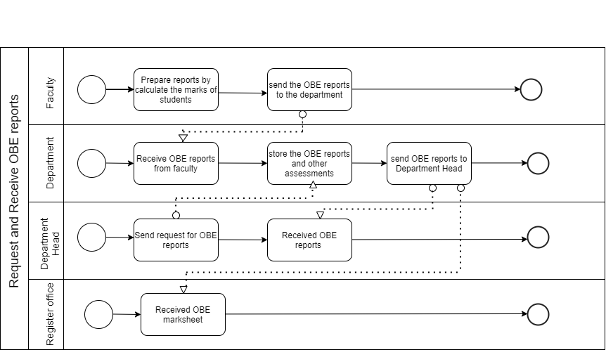

Figure2.2: Request and Receive OBE Reports

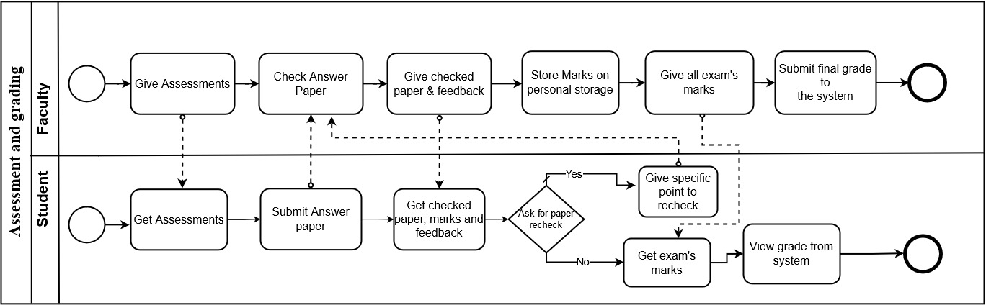

Figure 2.3: Assessment and grading

Figure 2.4: Manage Student and Faculty account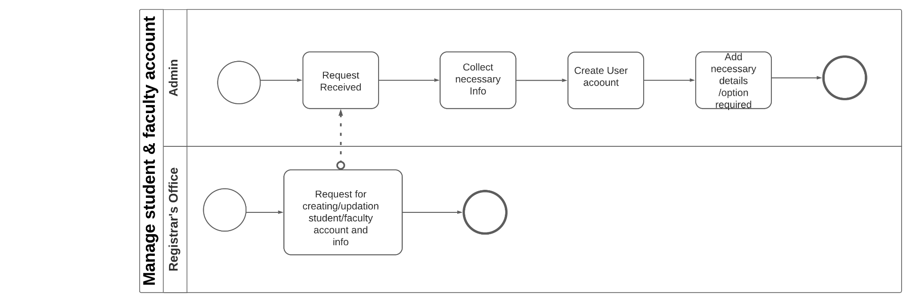

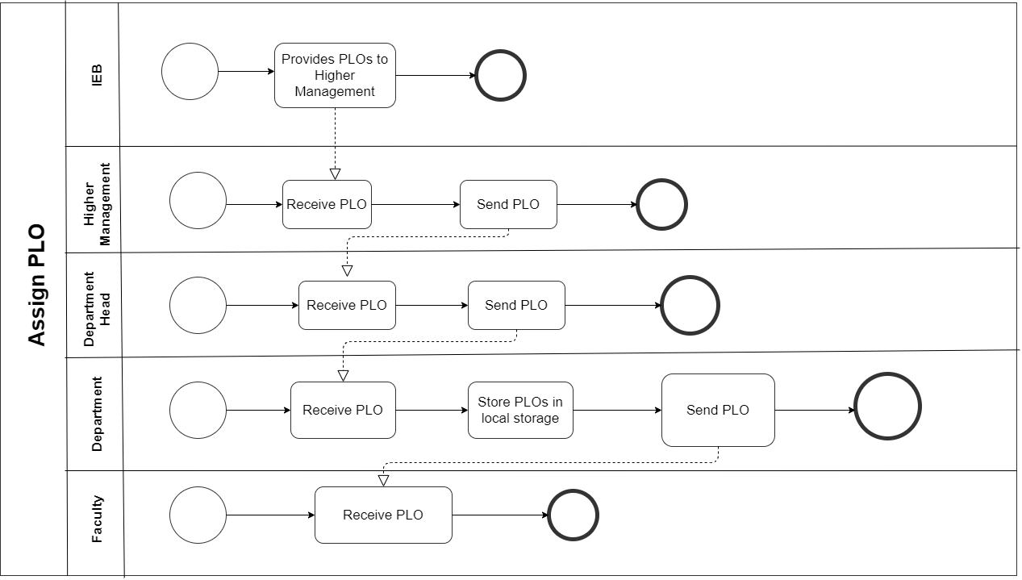

Figure 2.5: Assign PLO

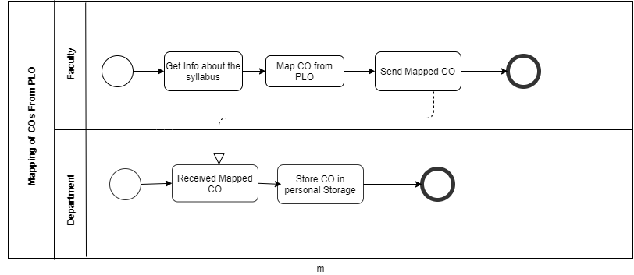

Figure 2.6: Mapping of COs from PLO

## **SECTION 2.6 :AS IS PROBLEM ANALYSIS**

| **Process Name** | **Stakeholders** | **Concerns(Problems)** | **Analysis(Reason of the problem)** | **Proposed Solution** |
| --- | --- | --- | --- | --- |
| Faculty submit COs & OBE reports to the department to register office to update the database | 1.Faculty  2.Department  3.Register Office | The faculty members provide the COs & OBE report to the department, then the department gives it to the register office to update into the database.  This process takes too much time and action. | This process takes a lot more action and time as the faculty has to store the data locally and then give it to the department. The department then sends it to the register office to update the data in the database. | We can establish direct contact with faculty members and the system to avoid the department and register office involvements to update the COs and OBE reports. So that the faculty members can update the COs and OBE reports directly. |
| Department Head request for OBE reports and performance report to the department | 1.Department Head.  2.Department | The head of the department requests for an OBE report and performance report of the students of the department. The department then sends it to the head of the department. | Each time the head of the department has to ask for data from the department. This is a manual process and takes time. | We can establish direct contact with the head of department and the system to avoid the department’s action to get the OBE report and the student performance report. So that the head can get the report and the reports directly from the system. |
| Higher authority request for student data | 1.Higher Authority  2.Register Office | The higher authority needs to get student data from the register office and the register office needs to collect it from the system. | Everytime the higher authority needs any data he has to request the register office for the data so it’s a long process to get the data and also a waste of time. | We can make a relationship between higher authority and system so that whenever the faculty submit students information, higher authority can collect it directly from the system and he doesn't have to ask anyone for the data. |
| Higher Management receive and distribute PLO | 1. Higher  Management  2. IEB  3. Department Head  4.Faculty | 1.Higher Management gets PLO from IEB.  2. Higher Management needs to send the PLO to the department head manually.  3.Department head needs to send the PLO to the faculty members manually. | 1.It will take time for Higher Management to get a PLO from IEB and forward it to the Department Head and again forward it to the faculty . | IEB will provide PLO to Higher Authority and Higher Authority will update PLO t o the system.  Department, Department Head and faculty will get all information about PLO on our system. |
| Monitor PLO performance | 1.Student  2.Faculty  3.Department  4.Department Head  5.Higher Authority | Students, faculty, department head or other staff can’t monitor PLO performance on the system. | The existing system doesn't have the feature of monitoring the PLO performance.  Thus, students, faculty, head of department or other staff can’t monitor PLO performance. | Our system will show the PLO performance for each member according to their needs. |

## 

## 

## **SECTION 2.7 : TO BE RICH PICTURE**

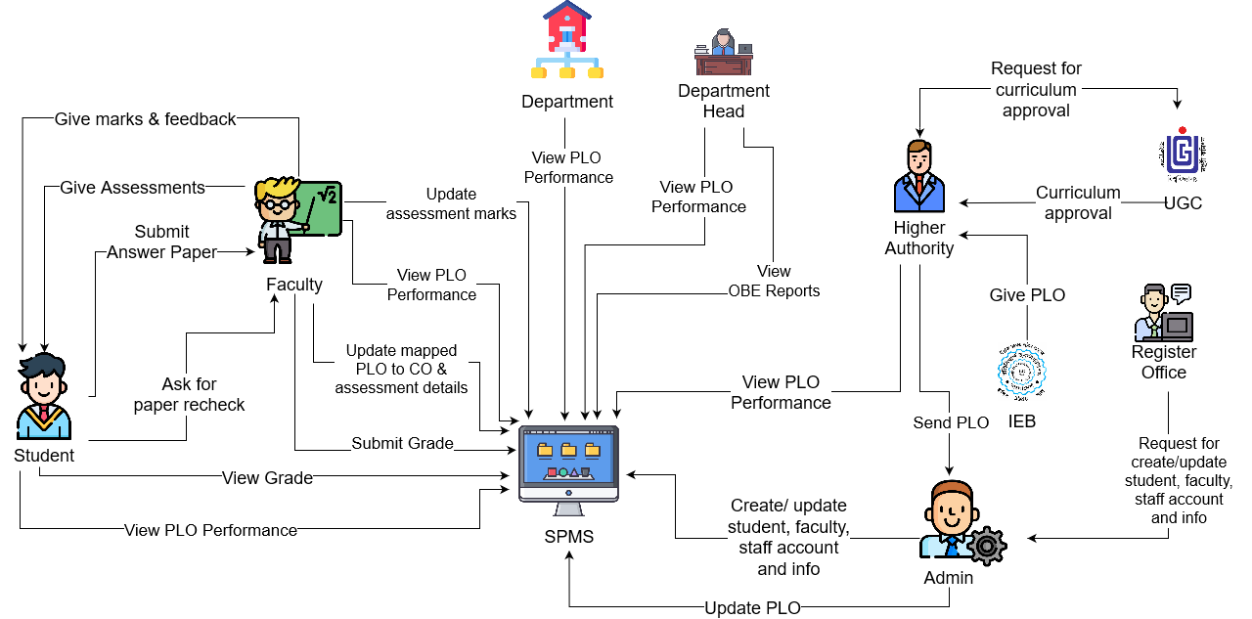

Figure 2.7: Rich Picture of Proposed System to Monitor Student Performance.

## 

## **SECTION 2.8 : TO BE SIX ELEMENTS ANALYSIS**

| **Process** | **System Roles** | | | | | |
| --- | --- | --- | --- | --- | --- | --- |
| **Human** | **Non Computing Hardware** | **Computing Hardware** | **Software** | **Database** | **Network & Communication** |
| Create or update users accounts | **Admin**  1. Can create new users' accounts using their certain information for the system.  2. Update or delete account’s information if needed. | **Pen and paper**  1. May used to record any information manually.  2. Hardcopy information may need to be used. | **Computer**  1. Used by the admin to access the system to create, update any accounts and store or view any information. | **SPMS**  1. Used to create or update users accounts.  **MS Excel**  1. Used to store related information for further uses. | **SPMS Database**  1. Used to store information of users accounts. | **Internet**  1.Used to access the system and create or update user’s accounts and store data in the database. |
| Give Assessment and grading | **Faculty**  1.Take quizzes, exams, midterm, final.  2.Give assignment and project.  3.Give marks & related feedback to the student.  4.Record all the marks of every assessment.  5.Recheck the answer paper if a student asks.  6.Change marks if needed.  7. Upload assessment mark to the system  8.upload the final grade to the system  **Student**  1.Submit an answer paper to the faculty.  2.Get marks and related feedback from the faculty.  3. Ask for an answer paper recheck if needed. | **Pen and  Paper**  1. Used to check students' answer papers.  2.Used by students for answering questions on paper. | **Computer**  1. Creating the marksheet of assessment marks.  2. Student View the marks and feedback. | **Excel Sheet**  1. Record all assessment marks, final grade on Excel Sheet or Google Sheet. | **SPMS Database**  1. Used to store and update student data. | **Internet**  1.Used to access the system for updating the marks, grade and other resources.  **Email**  1. Used for sending information or material to one another. |
| Student view final grade and PLO Performance | **Student**  1. Login into the system using id and password.  2. View semester wise final grade.  4. View their PLO Performance  according to different criteria. Such as course wise, semester wise, comparison of attempt vs achieved. | **Pen and  Paper**  1. May used to record any information manually. | **Computer & Mobile**  1. Used to access the SPMS system. | **SPMS**  1. Used to view students' profiles and view information according to their needs. | **SPMS Database**  1. Used to store the grade and other performance data. | **Internet**  1. Used to access the SPMS system to view information. |
| Curriculum Activities Request/Approval | **Higher Authority** 1.Send the Curriculum booklet to the UGC for Approval.  2.Edit the booklet if it needs any change.  3.Receive back the booklet after being reviewed.  **UGC**  1. Receives the  Curriculum  booklet from  the Higher Authority.  2. Reviews the booklet if it needs to  change. Then  send back with feedback to  the Higher Authority. Then again  receive the changed booklet and review then approve if everything is ok. Send back the curriculum to Higher authority. | **Paper and Pen**  1. It is used to  print the booklet. | **Computer**  1. Used to send the Curriculum  by mail to the UGC. Also used for  editing and  updating the  Curriculum  booklet doc  File.  **Printer**  1. Used by the Higher Authority to print the curriculum  Booklet. | **MS Word**  1. Used to edit  or update the  Curriculum file.  **Gmail**  1. Used to send  mail to the  UGC.  **Operating**  **System**  1. Any type of OS used by the users.e.g.  Windows,  Linux.  **Adobe Acrobat**  a) Used to view the PDF file. | **Personal Storage**  1. Higher Authority  access the  data to edit  or update  the  Curriculum Activities | **Internet**  **Connection**  1. To send  or receive mail. |
| Receive PLO and update it into the system | **IEB**  1.Give the PLO to the Higher Authority.  **Higher Authority**  1.Receive the PLO from the IEB and send it to Admin.  **Admin**  1. Admin update PLO into the system. | **Pen and Paper**  1.Is used for preparing PLO hardcopy. | **Computer**  1.Is used for making softcopies of PLO  **Printer**  Print hardcopy of PLO | **SPMS**  1.Is used as a user interface to update the PLO to the system. | **SPMS Database**  1.Is used for storing final copies of PLO. | **Internet**  1.Is used for sending information.  **Mobile and Telephone**  1.Is used for communicating information among one another. |
| View PLO Performance | **Higher Authority**  1. Login to the system using Id, password.  2. View PLO Performance  according to different criteria. Such as course-wise, semester-wise, instructor-wise, individual students-wise  **Department Head** 1. Login to the system using Id, password.  **Department**  1. Login to the system using Id, password.  **Faculty**  1. Login to the system using Id, password.  **Student**  1. Login to the system using Id, password.  2. View their PLO Performance  according to different criteria. Such as course wise, semester wise, comparison of attempt vs achieved. | **Pen and paper**  1. May used to record any information manually. | **Computer**  1. Used to access the SPMS system to view the PLO performance data. | **SPMS**  1. Used to view students' profiles and view information according to their needs. | **SPMS Database**  1. Used to store the performance data. | **Internet**  1. Used to access the SPMS system to view information. |

## **SECTION 2.9 : TO BE PROCESS DIAGRAM**

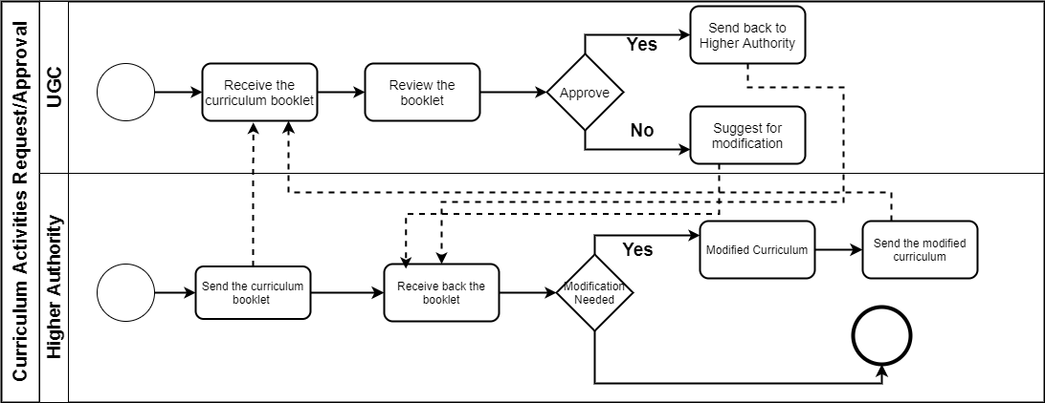

Figure 2.8-Curriculum Activities Request/Approval

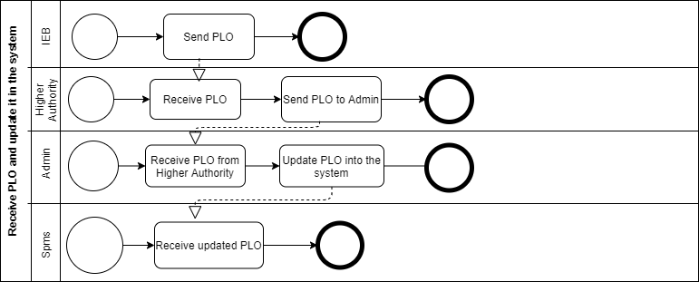

Figure 2.9- Receive PLO and update it in the system

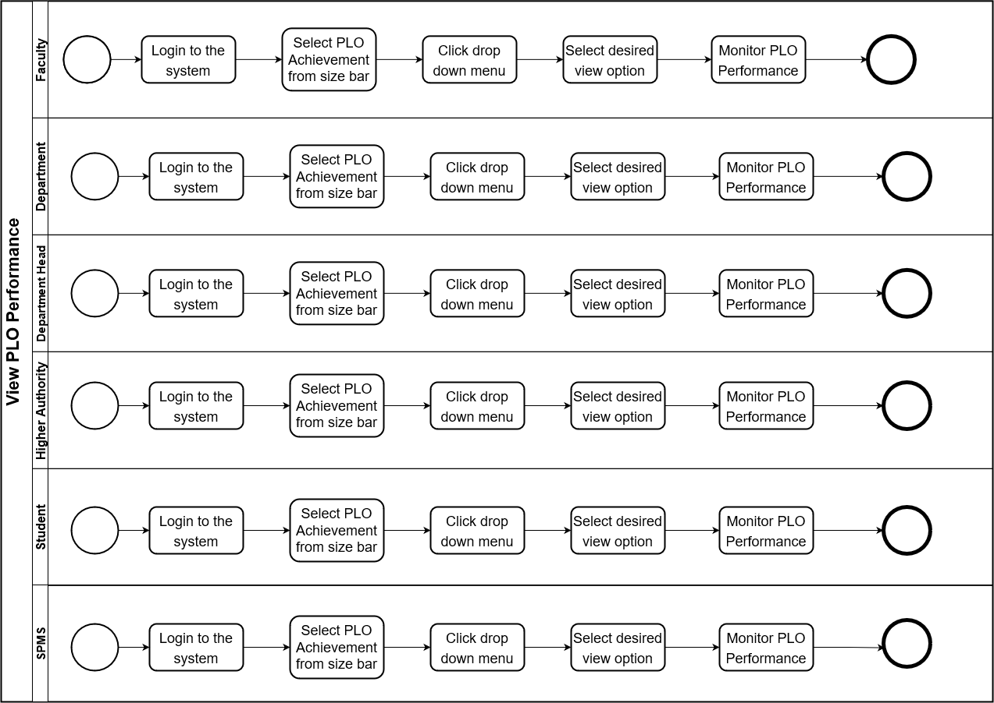

Figure 2.10: View PLO Performance

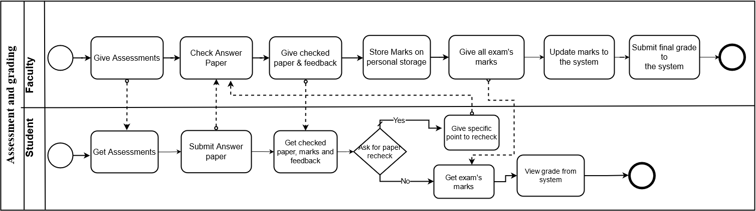

Figure 2.11: Assessment and Grading

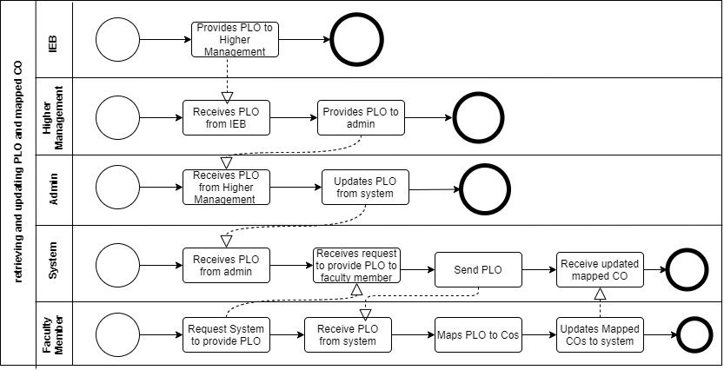

Figure 2.12: Retrieving and updating PLO and mapped CO

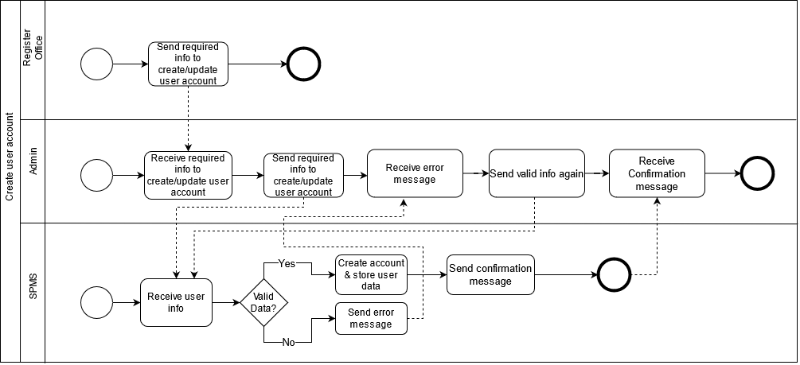

Figure 2.13: Create User Account

# **CHAPTER 3: LOGICAL SYSTEM DESIGN**

## **SECTION 3.1 : BUSINESS RULE**

1. A university has one or many schools. A School belongs to one university.
2. A school has one or many departments. A department belongs to one school.
3. A department has many faculty. A faculty is managed by one department.
4. A program enrolls many students. Each student is enrolled by exactly one program. A PLO is contained by exactly one program. A program must consist of many PLOs.
5. A faculty must have many marksheet to evaluate the students. A marksheet must be evaluated by exactly one faculty. An enrollment belongs to exactly one marksheet. A marksheet has exactly one enrollment.
6. A faculty is assigned to many sections.
7. Each assessment is assigned by exactly one section.
8. Students have many enrollments. An enrollment must have exactly one student. A section must have a lot of enrollment. An enrollment must have many sections
9. An assessment is assigned to many students. Each student must receive many assessments. An assessment must have multiple Cos. A CO belongs to exactly one assessment.
10. A CO belongs to exactly one course. A course must have many Cos. A CO belongs to exactly one PLO. A PLO must have many COs

## 

## 

## 

## 

## **SECTION 3.2 : ENTITY RELATIONSHIP DIAGRAM (ERD)**

## 

## **SECTION 3.3: RELATIONAL SCHEMA**

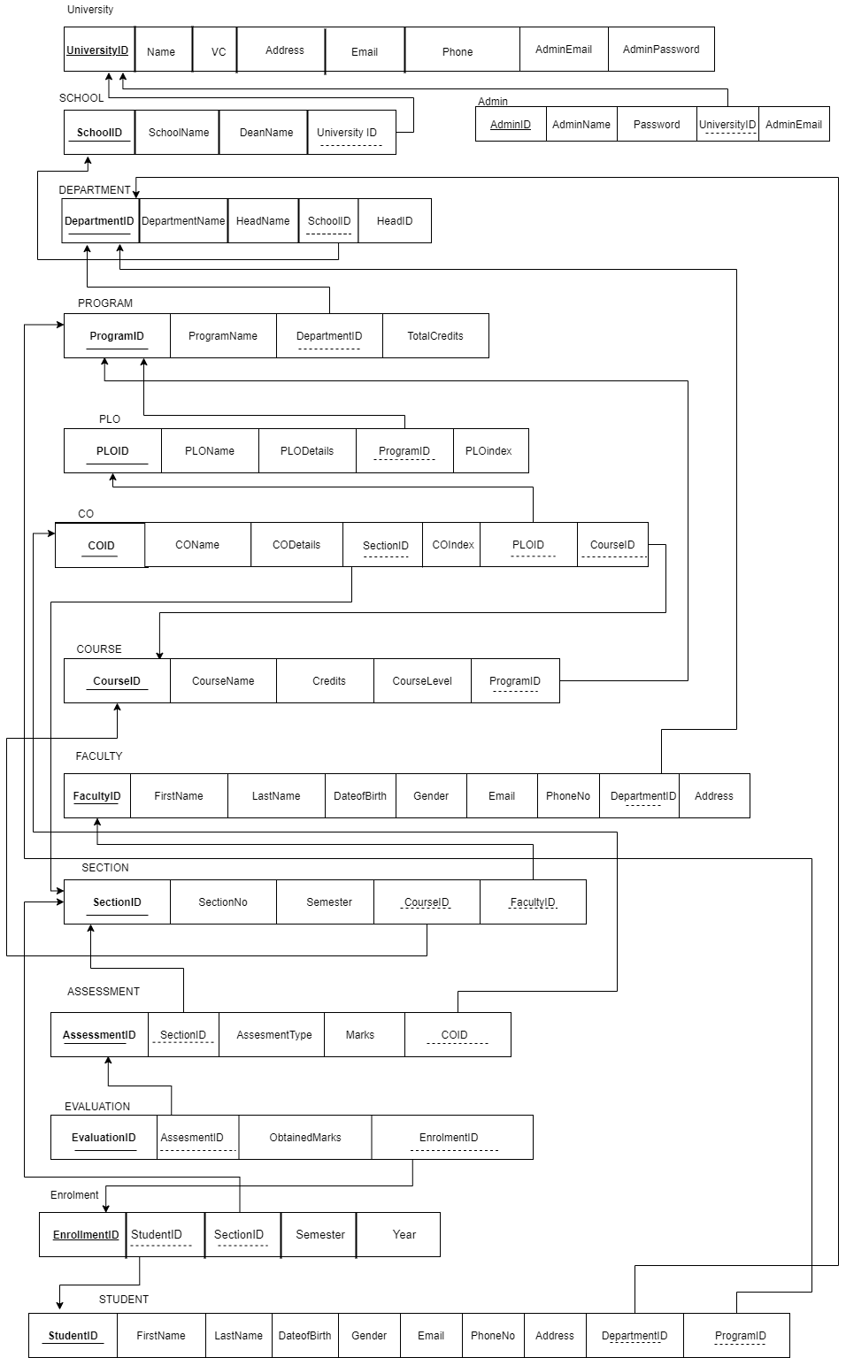

## **SECTION 3.3:NORMALIZATION**

| University | UniversityID | u1 | Program | ProgramID | p1 |
| --- | --- | --- | --- | --- | --- |
| Name | u2 | ProgramName | p2 |
| Address | u3 | DepartmentID | d1 |
| Email | u4 | TotalCredits | p3 |
| VC | u5 | Student | StudentID | r1 |
| Phone | u6 | FirstName | r2 |
| School | SchoolID | s1 | LastName | r3 |
| SchoolName | s2 | DateofBirth | r4 |
| DeanName | s3 | Gender | r5 |
| UniversityID | u1 | Email | r6 |
| Department | DepartmentID | d1 | PhoneNo | r7 |
| DepartmentName | d2 | Address | r8 |
| HeadName | d3 | DepartmentID | d1 |
| HeadID | d4 | ProgramID | p1 |
| SchoolID | s1 | Section | SectionID | g1 |
| faculty | FacultyID | f1 | SectionNo | g2 |
| FirstName | f2 | Semester | g3 |
| LastName | f3 | CourseID | c1 |
| DateofBirth | f4 | FacultyID | f1 |
| Gender | f5 | Evaluation | EvaluationID | e1 |
| Email | f6 | AssessmentID | a1 |
| PhoneNo | f7 | ObtainedMarks | e2 |
| Address | f8 | EnrollmentID | l1 |
| DepartmentID | d1 | PLO | PLOID | b1 |
| Enrollment | EnrollmentID | l1 | PLOName | b2 |
| StudentID | r1 | PLODetails | b3 |
| SectionID | g1 | ProgramID | p1 |
| Semester | l2 | PLOindex | b4 |
| Year | l3 | CO | COID | c1 |
| Assessment | AssessmentID | a1 | COName | c2 |
| SectionID | g1 | CODetails | c3 |
| AssessmentType | a2 | SectionID | g1 |
| Marks | a3 | COindex | c4 |
| COID | c1 | PLOID | b1 |
| Course | CourseID | i1 | CourseID | i1 |
| CourseName | i2 | Admin | AdminID | h1 |
| Credits | i3 | AdminName | h2 |
| CourseLevel | i4 | AdminEmail | h3 |
| ProgramID | p1 | Password | h4 |
|  |  | UniversityID | u1 |

| u1**➔** | u2,u3,u4,u5,u6 | p1➔ | p2,p3,d1 |
| --- | --- | --- | --- |
| s1➔ | s2,s3,u1 | r1➔ | r2,r3,r4,r5,r6,r7,r8,d1,p1 |
| d1➔ | d2,d3,d4,s1 | g1➔ | g2,g3,c1,f1 |
| f1➔ | f2,f3,f4,f5,f6,f7,f8,d1 | e1➔ | e2,a1,l1 |
| l1➔ | l2,l3,r1,g1 | b1➔ | b2,b3,b4,p1 |
| a1➔ | a2,a3,c1,g1 | c1➔ | c2,c3,c4,b1,g1,i1 |
| i1➔ | i2,i3,i4,p1 | h1➔ | h2,h3,h4,u1 |

| UniversityID➔ | Name,Address,Email,VC,Phone |
| --- | --- |
| SchoolID➔ | SchoolName,DeanName,UniversityID |
| DepartmentID➔ | DepartmentName,HeadName,HeadID,SchoolID |
| FacultyID➔ | FirstName,LastName,DateofBirth,Gender,Email,PhoneNo,Address,  DepartmentID |
| EnrollmentID➔ | Semester,year,StudentID,SectionID |
| AssessmentID➔ | AssessmentType,Marks,COID,SectionID |
| CourseID➔ | CourseName,Credits,CourseLevel,ProgramID |
| ProgramID➔ | ProgramName,TotalCredits,DepartmentID |
| StudentID➔ | FirstName,LastName,DateofBirth,Gender,Email,Address,DepartmentID,  ProgramID |
| SectionID➔ | SectionNo,Semester,CourseID,FacultyID |
| EvaluationID➔ | ObtainedMarks,AssessmentsID,EnrollmentID |
| PLOID➔ | PLOName,PLODetails,PLOIndex,ProgramID |
| COID➔ | COName,CODetails,COIndex,PLOID,SectionID,CourseID |
| AdminID➔ | AdminName,AdminEmail,Password,UniversityID |

**1NF:**

| u1 | u2 | u3 | u4 | u5 | u6 | s1 | s2 | s3 | d1 | d2 | d3 | d4 | f1 | f2 | f3 | f4 | f5 | f6 | f7 | f8 | l1 |
| --- | --- | --- | --- | --- | --- | --- | --- | --- | --- | --- | --- | --- | --- | --- | --- | --- | --- | --- | --- | --- | --- |

| l2 | l3 | a1 | a2 | a3 | i1 | i2 | i3 | i4 | p1 | p2 | p3 | r1 | r2 | r3 | r4 | r5 | r6 | r7 | r8 | g1 | g2 |
| --- | --- | --- | --- | --- | --- | --- | --- | --- | --- | --- | --- | --- | --- | --- | --- | --- | --- | --- | --- | --- | --- |

| g3 | e1 | e2 | b1 | b2 | b3 | b4 | c1 | c2 | c3 | c4 | h1 | h2 | h3 | h4 |
| --- | --- | --- | --- | --- | --- | --- | --- | --- | --- | --- | --- | --- | --- | --- |

**2NF:**

R11

| e1 | e2 | a1 | a2 | a3 | c1 | c2 | c3 | c4 | b1 | b2 | b3 | b4 | p1 | p2 | p3 | d1 | d2 | d3 | d4 | s1 | s2 |
| --- | --- | --- | --- | --- | --- | --- | --- | --- | --- | --- | --- | --- | --- | --- | --- | --- | --- | --- | --- | --- | --- |

| s3 | u1 | u2 | u3 | u4 | u5 | u6 | g1 | g2 | g3 | i1 | i2 | i3 | i4 | f1 | f2 | f3 | f4 | f5 | f6 | f7 | f8 |
| --- | --- | --- | --- | --- | --- | --- | --- | --- | --- | --- | --- | --- | --- | --- | --- | --- | --- | --- | --- | --- | --- |

| l1 | l2 | r3 | r1 | r2 | r3 | r4 | r5 | r6 | r7 | r8 |
| --- | --- | --- | --- | --- | --- | --- | --- | --- | --- | --- |

R22

| h1 | h2 | h3 | h4 | u1 | u2 | u3 | u4 | u5 | u6 |
| --- | --- | --- | --- | --- | --- | --- | --- | --- | --- |

**3NF:**

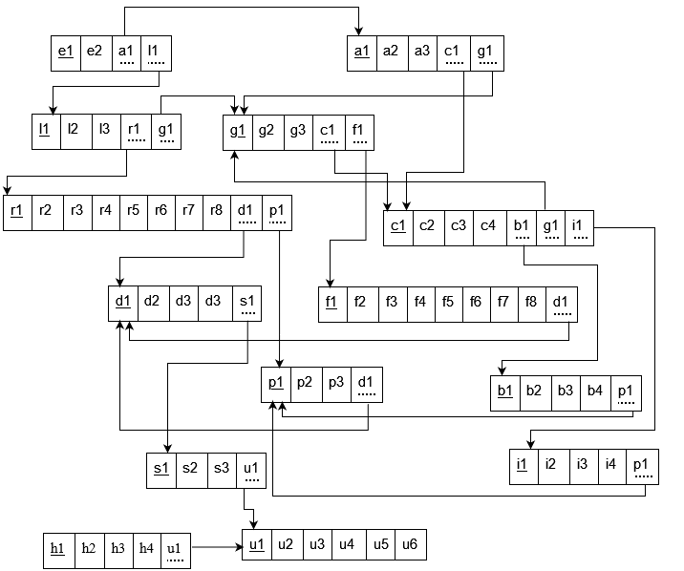  
  
**BCNF:** Here all the relations are in the BCNF.

## **SECTION 3.4:DATA DICTIONARY**

University

| Name | Data Type | Size | Remark |
| --- | --- | --- | --- |
| Unive UniversityID | VARCHAR | 10 | This is the foreign key of the university table. |
| UniversityName | VARCHAR | 50 | This refers to the name of the university Example: IUB,EWU,NSU |
| UniversityAddress | VARCHAR | 100 | This is the permanent address of the university. That indicates the exact location of a university.Example :House no,road, block. |
| UniversityE-mail | VARCHAR | 50 | This is the online contact address of a university. Example:  abc@name.edu.bd. |
| Vice chancellor | VARCHAR | 50 | This is the name of the Vice chancellor. |
| Phone | NUMBER | 15 | This is the official contact number of a university. |

School

| Name | Data Type | Size | Remark |
| --- | --- | --- | --- |
| SchoolID | VARCHAR | 10 | This is the primary key of this relation.This contains the ID of the school. |
| SchoolName | VARCHAR | 100 | This is the name of the School. Example:  Computer Science(CS). |
| DeanName | VARCHAR | 100 | This is the name of the school dean. |
| UniversityID | VARCHAR | 10 | This is the foreign key of the university table. |

Department

| Name | Data Type | Size | Remark |
| --- | --- | --- | --- |
| DepartmentName | VARCHAR | 200 | This is the name of the Department. Example: Engineering , Business department etc. |
| DepartmentID | VARCHAR | 10 | This is the primary key of this relation.This contains the ID of the Faculty. |
| HeadName | VARCHAR | 50 | This is the name of the Department Head. |
| HeadID | VARCHAR | 10 | This refers to the unique id of the Head. |
| SchoolID | VARCHAR | 10 | This is the foreign key of the school table. |

Faculty

| Name | Data Type | Size | Remark |
| --- | --- | --- | --- |
| FacultyID | VARCHAR | 10 | This is the primary key of this relation.This contains the ID of the Faculty. |
| FirstName | VARCHAR | 10 | This is the Given Name of the Student. |
| LastName | VARCHAR | 10 | This is the Surname of a student. |
| DateofBirth | DATETIME | DD-MM-YYYY | This refers to the date of birth of a student. Example:  01-02-2021 |
| Gender | VARCHAR | 10 | This indicates the gender of a Faculty. Example: “M”/ “F” |
| Email | VARCHAR | 100 | This is the email address of a student. Example:  id@name.edu.bd |
| PhoneNo | VARCHAR | 15 | This is the contact number of a student. Example:  017…….. |
| Address | VARCHAR | 100 | This is the permanent/ temporary address of a faculty. Example:  House no, road, Block: . |
| DepartmentID | VARCHAR | 10 | This is the foreign key of the department table. |

Enrollment

| Name | Data Type | Size | Remark |
| --- | --- | --- | --- |
| EnrollmentID | INTEGER | 10 | This is the primary key from enrolment table |
| Semester | VARCHAR | 20 | It is the semester of student enrollment. |
| Year | YEAR | YYYY | It is the year of student enrollment. |
| StudentID | INTEGER | 10 | This is the foreign key of the student table. |
| SectionID | INTEGER | 10 | This is the foreign key of the section table. |

Assessment

| Name | Data Type | Size | Remark |
| --- | --- | --- | --- |
| AssessmentID | INTEGER | 10 | This is the primary key of the Assessment. |
| AssessmentType | VARCHAR | 30 | This is the primary key of the Assessment. |
| Marks | FLOAT | 10 | This is the mark obtained by the students in the assessment/ project/mid. Example:  Mid: 23  Final: 45  Project: 24 |
| COID | INTEGER | 10 | This is foreign key from the CO table. |
| SectionID | INTEGER | 10 | This is the foreign key for the section table. |

Course

| Name | Data Type | Size | Remark |
| --- | --- | --- | --- |
| CourseID | VARCHAR | 10 | This is the primary key of the Course. |
| CourseName | VARCHAR | 250 | This refers to the name of the course. |
| Credits | INTEGERS | 10 | These are the credits of each course. |
| CourseLevel | VARCHAR | 10 |  |
| ProgramID | VARCHAR | 10 | This is the foreign key of the program table. |

Program

| Name | Data Type | Size | Remark |
| --- | --- | --- | --- |
| ProgramID | VARCHAR | 10 | This is the Primary Key for a Program Example: ”CSE”. |
| ProgramName | VARCHAR | 10 | This is the name of the program. Example: “ Bachelor of Science, Bachelors of Business Administration etc ” |
| TotalCredits | INTEGER | 10 | This is the number of credits in a program. |
| DepartmentID | VARCHAR | 10 | This is the foreign key of the department table. |

Student

| Name | Data Type | Size | Remark |
| --- | --- | --- | --- |
| StudentID | VARCHAR | 10 | This is the primary key of the Student Table : |
| FirstName | VARCHAR | 50 | This is the first Name of student.Example :Asif |
| LastName | VARCHAR | 50 | This is the last Name of student.Example :Ahmad |
| DateofBirth | DATETIME | DD-MM-YYYY | This is the date of birth of the student. Example: 02-06-1999 |
| Gender | VARCHAR | 10 | This indicates the gender of a student. Example: “M”/ “F” |
| Email | VARCHAR | 50 | This is the email address of the student. |
| Address | VARCHAR | 100 | This is the permanent/ temporary address of a student. Example:  House no, road, Block’ |
| DepartmentID | VARCHAR | 15 | This is the foreign key of the department table. |
| ProgramID | VARCHAR | 15 | This is the foreign key of the program table. |

Section

| Name | Data Type | Size | Remark |
| --- | --- | --- | --- |
| SectionID | INTEGER | 10 | This is the primary key of the section table. |
| SectionNo | INTEGER | 10 | This is the number of sections in a course. |
| Semester | VARCHAR | 10 | It is the semester of student enrollment. |
| CourseID | INTEGER | 10 | This is the foreign key of the course table. |
| FacultyID | VARCHAR | 10 | This is the foreign key of the faculty table. |

Evaluation

| Name | Data Type | Size | Remark |
| --- | --- | --- | --- |
| EvaluationID | INTEGER | 10 | This is the primary key of the evaluation table. |
| ObtainedMarks | FLOAT | 10 | This is the mark obtained by the students in the assessment/ project/mid. Example:  Mid: 23  Final: 45  Project: 24 |
| AssessmentsID | INTEGER | 10 | This is the foreign key of the Assessments table. |
| EnrollmentID | INTEGER | 10 | This is the foreign key of the Enrollments table. |

PLO

| Name | Data Type | Size | Remark |
| --- | --- | --- | --- |
| PLOID | VARCHAR | 10 | This is the primary key for Program Learning Outcome. Example: “PLO1” |
| PLOName | VARCHAR | 10 | This is the name of the PlO. |
| PLODetails | VARCHAR | 50 | This is the details of the Program Learning Outcome. Example: knowledge, |
| PLOIndex | VARCHAR | 10 | This is the number of indexes of PlO. |
| ProgramID | VARCHAR | 10 | This is the foreign key of the Program table. |

CO

| Name | Data Type | Size | Remark |
| --- | --- | --- | --- |
| COID | VARCHAR | 10 | This is the Primary Key for Course Outcome. Example:Co1 |
| COName | VARCHAR | 100 | This is name of the CO |
| CODetails | VARCHAR | 50 | This is details of CO |
| COIndex | VARCHAR | 10 | This is the number of indexes of CO. |
| PLOID | VARCHAR | 10 | This is the foreign key of the PlO table. |
| SectionID | INTEGER | 10 | This is the foreign key of the Section table. |
| CourseID | INTEGER | 10 | This is the foreign key of the course table. |

Admin

| Name | Data Type | Size | Remark |
| --- | --- | --- | --- |
| AdminID | VARCHAR | 10 | This is the primary key.This contains the ID of the Admin. |
| AdminName | VARCHAR | 50 | This is the name of the admin. |
| AdminEmail | VARCHAR | 50 | This is the email address of the admin. |
| Password | VARCHAR | 20 | This is admin password |
| UniversityID | VARCHAR | 20 | This is the foreign key of the admin table. |

# 

# **CHAPTER 4: PHYSICAL SYSTEM DESIGN**

## **SECTION 4.1: INPUT FORMS**

Create Assignment:

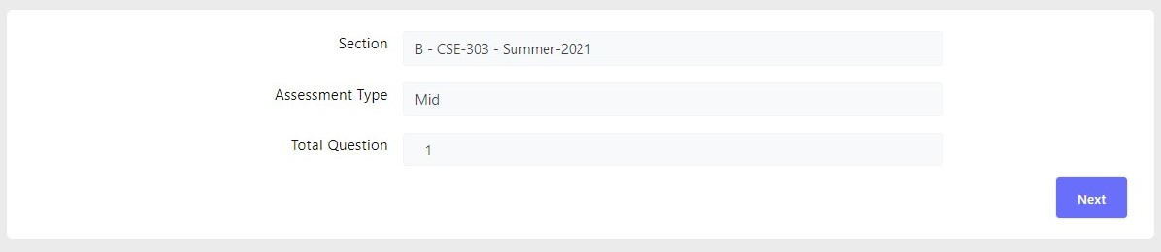

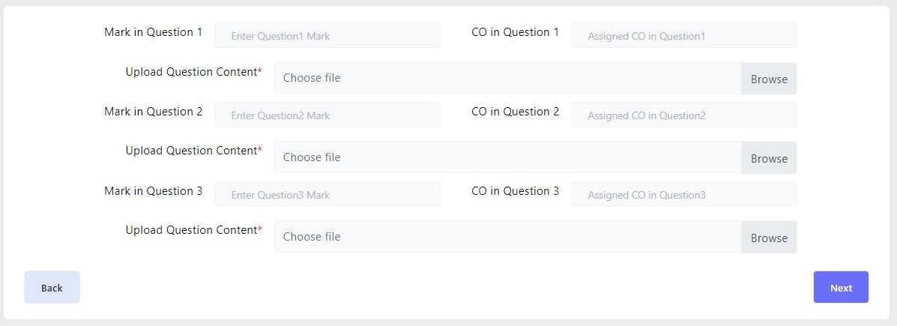

Add Evaluation File:

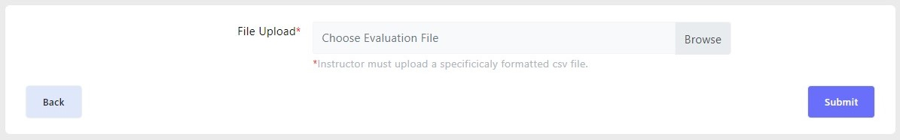

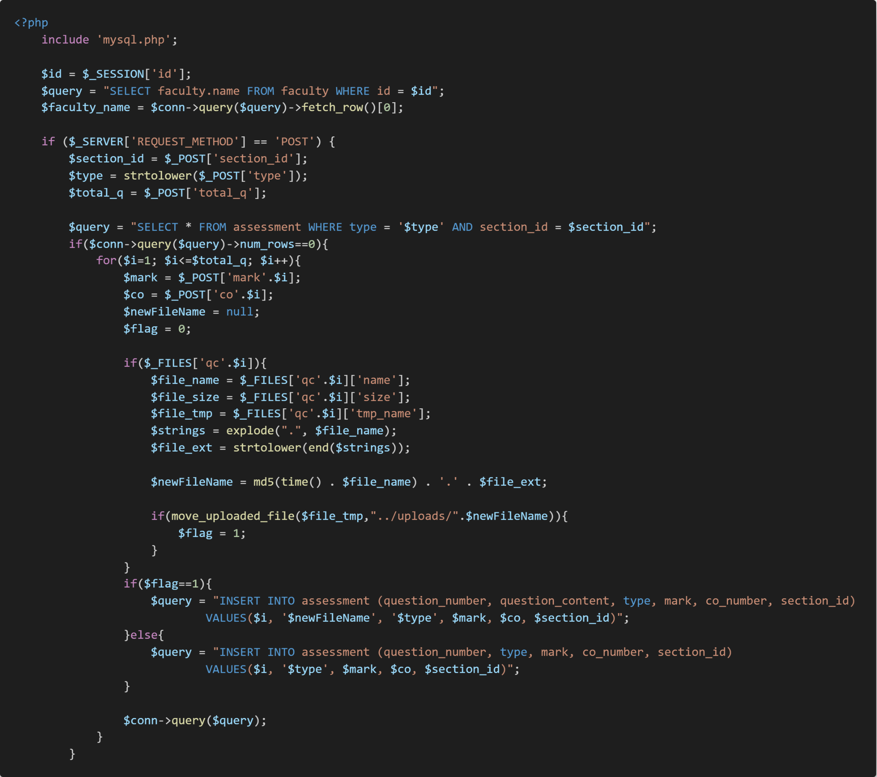

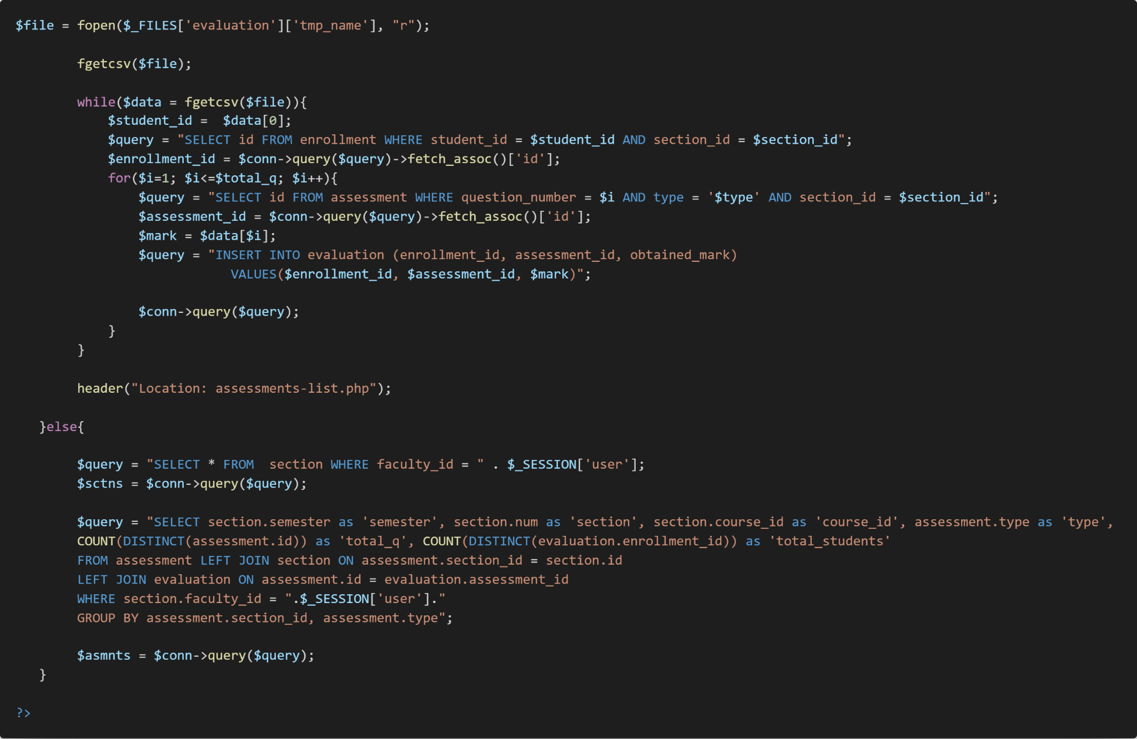PLO of the Program

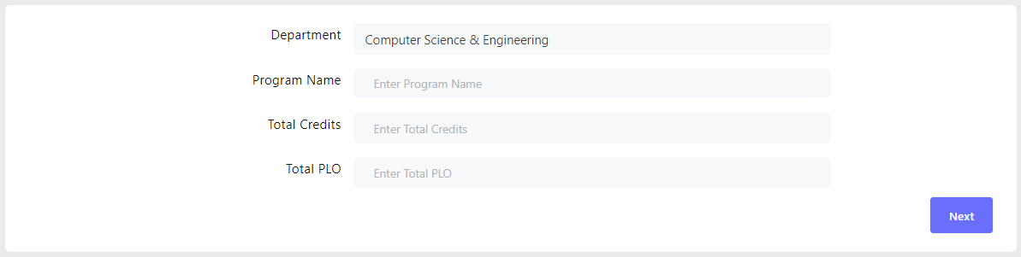

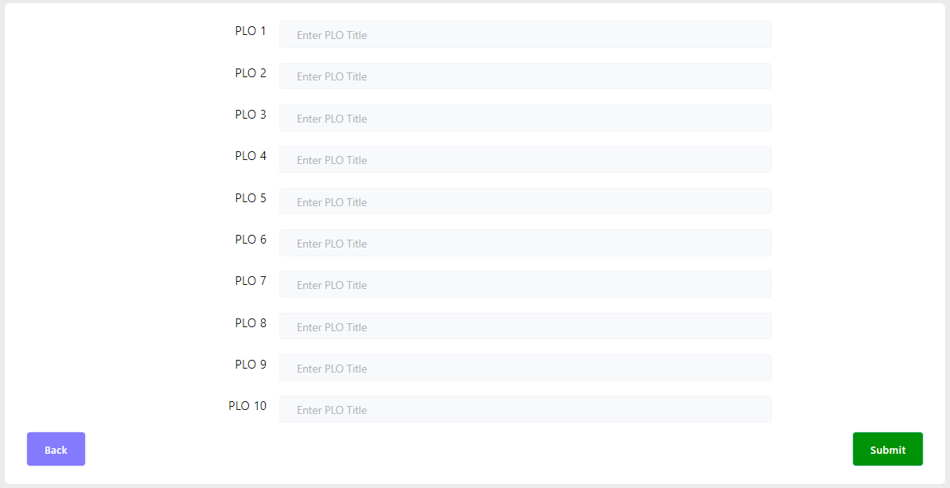

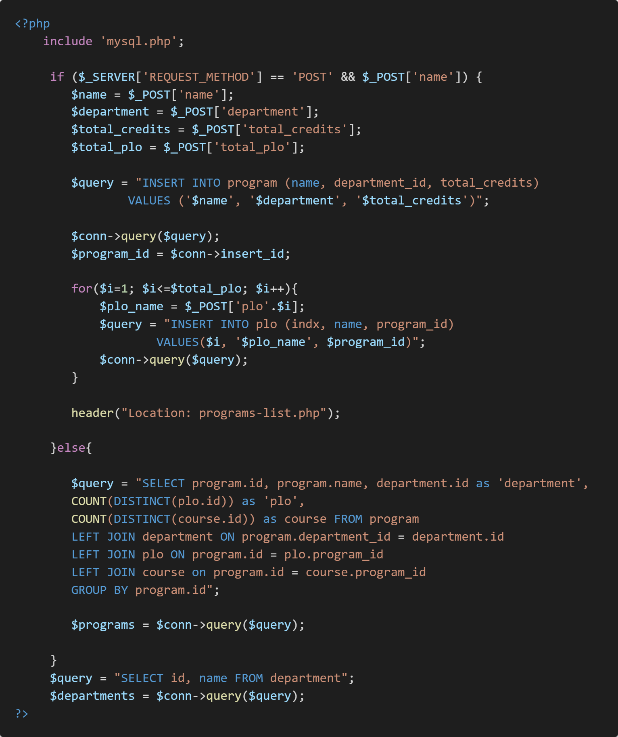

CO of the Course:

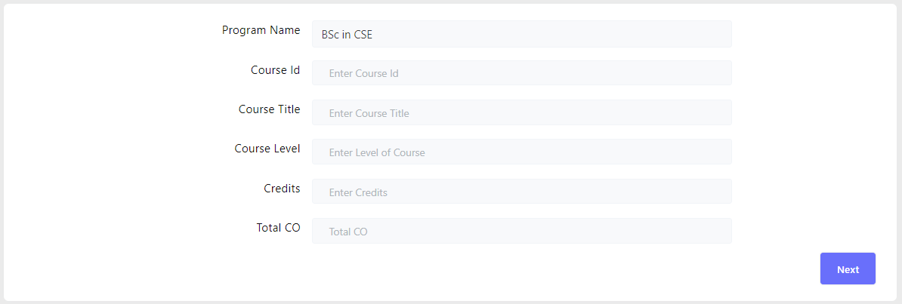

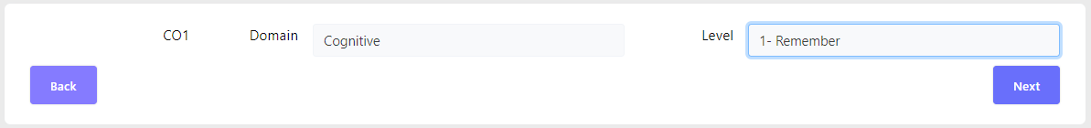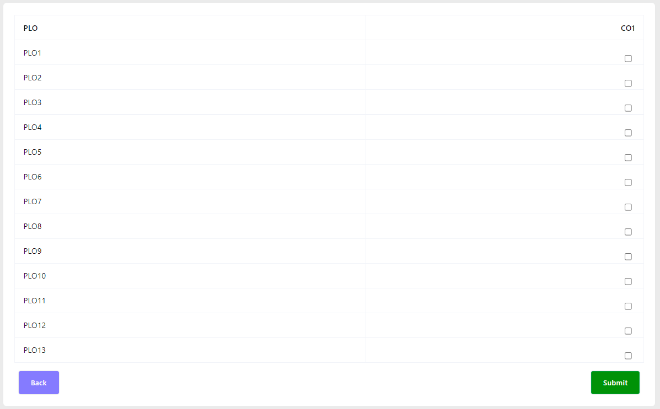

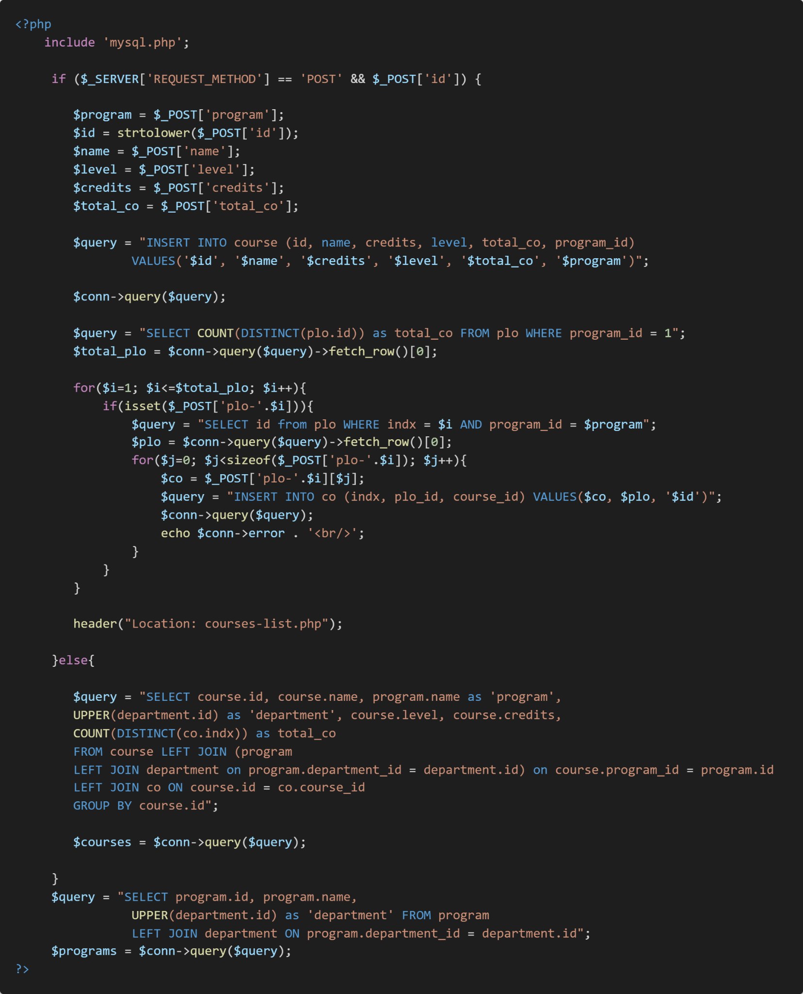

## **SECTION 4.2: OUTPUT REPORT**

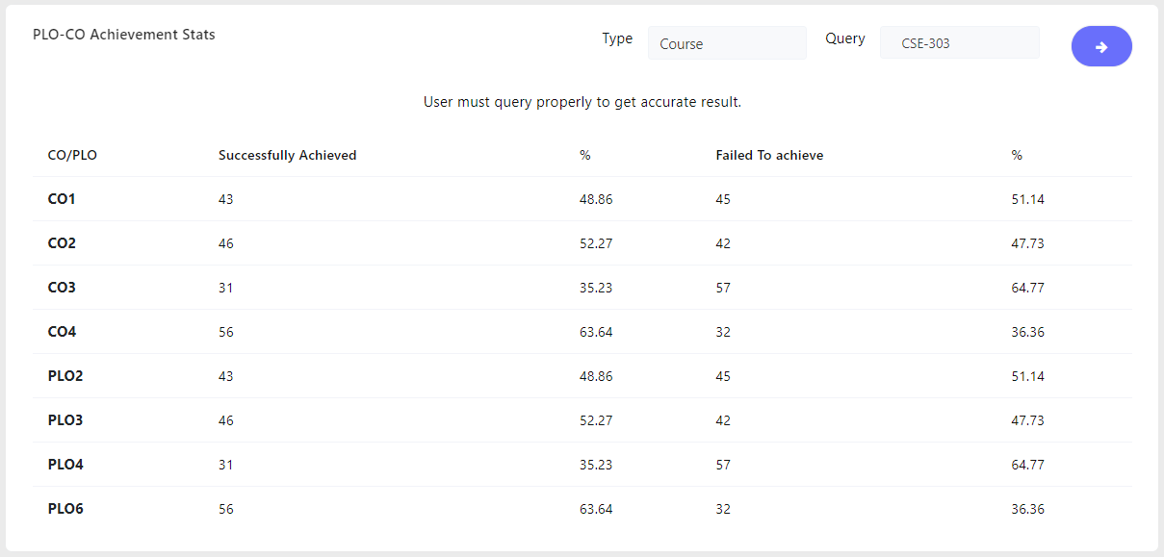

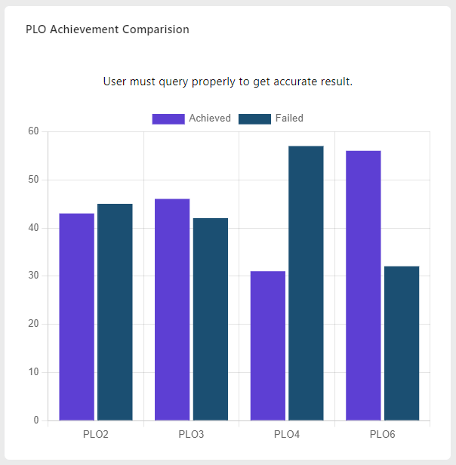

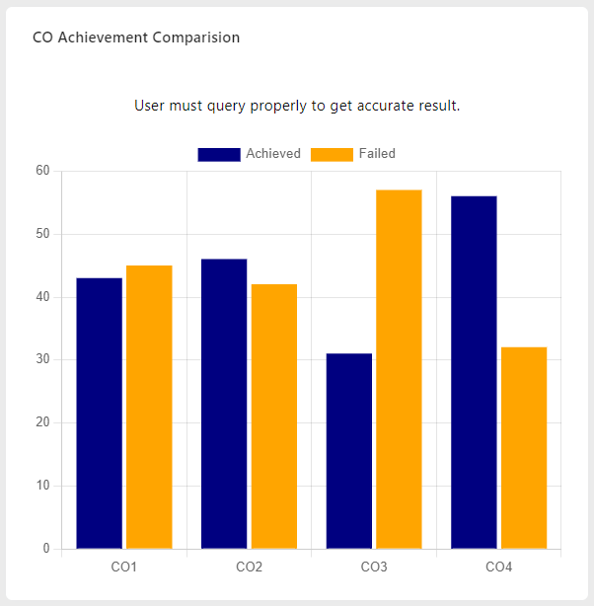

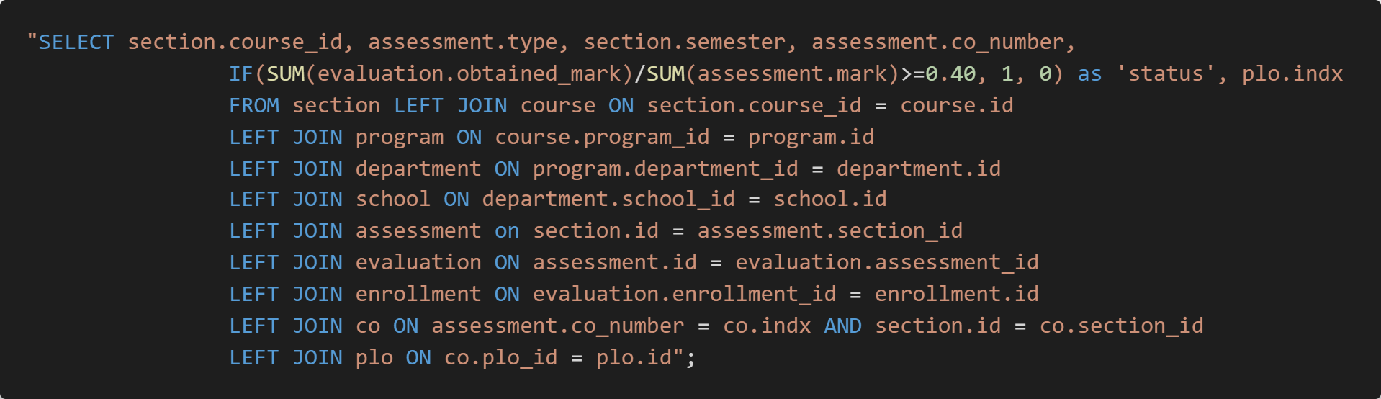

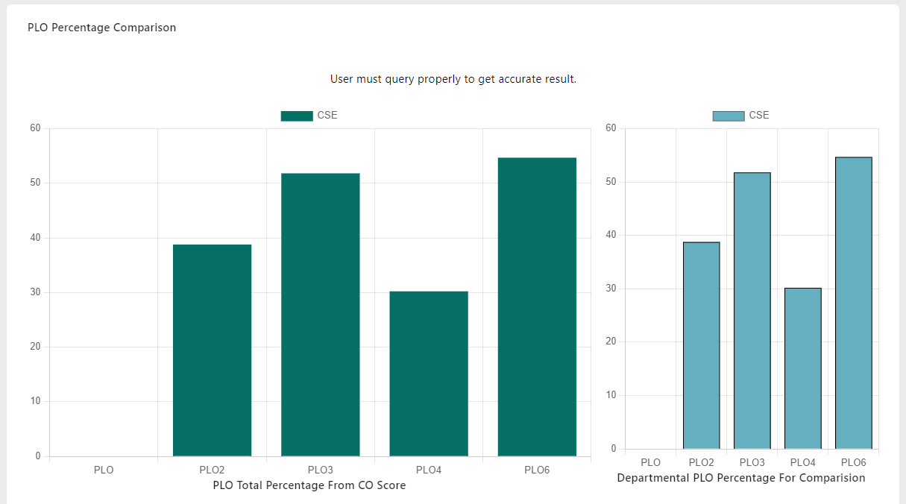

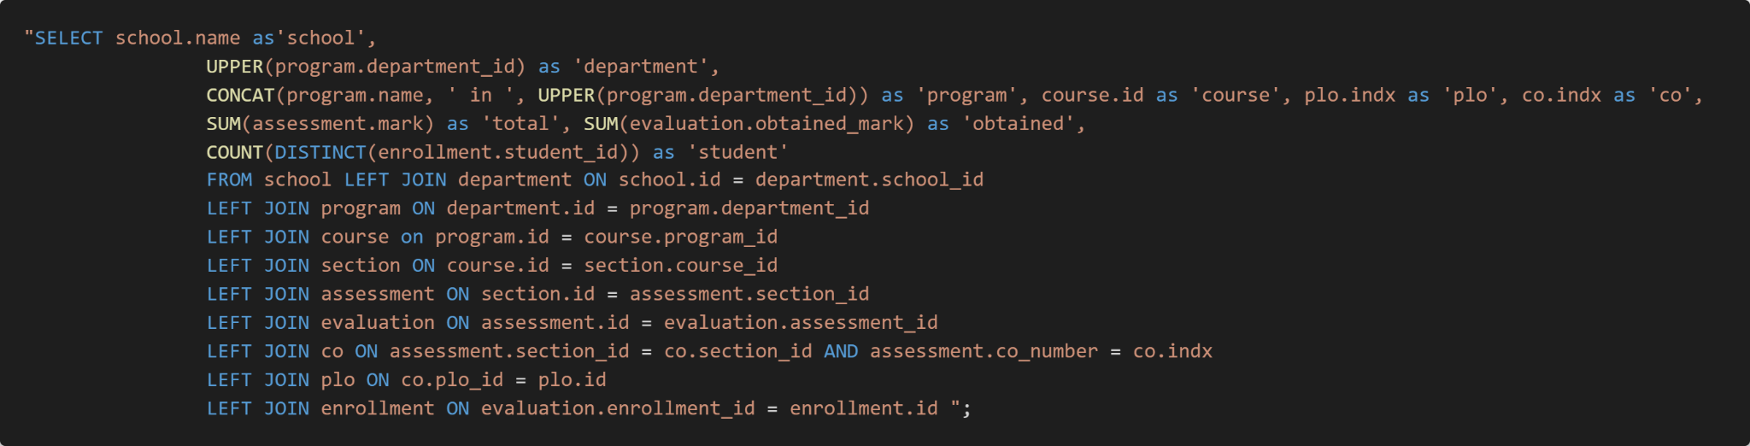

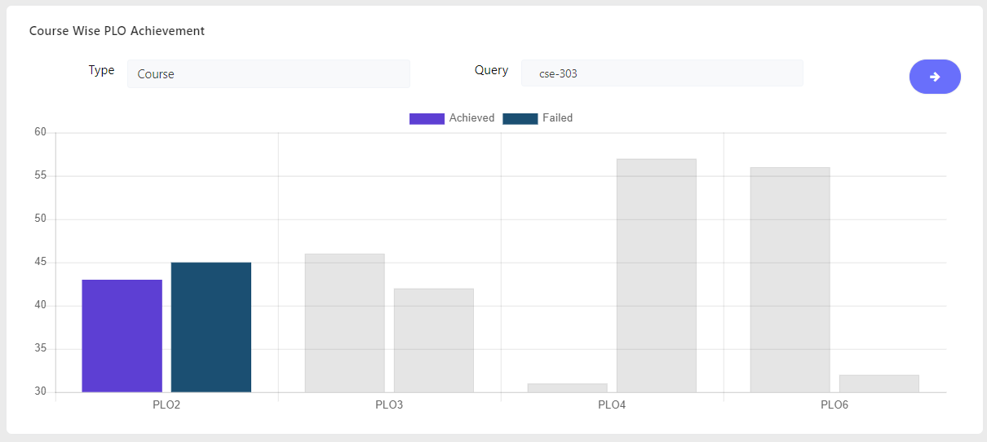



# 

# 

# 

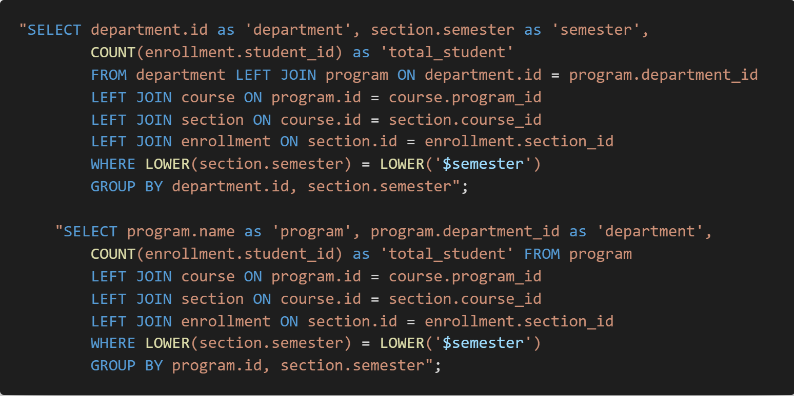

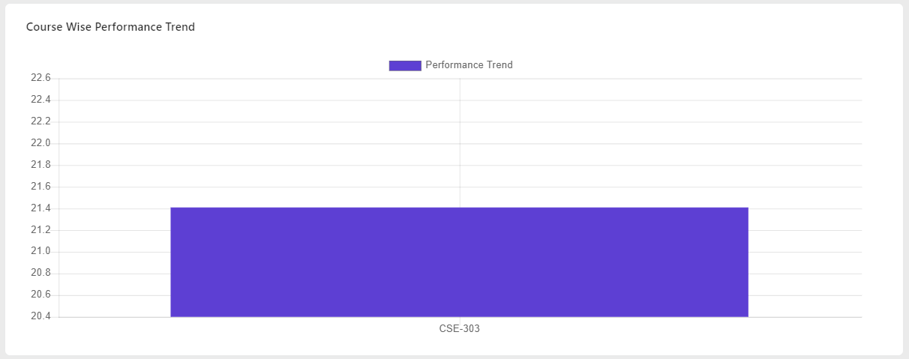

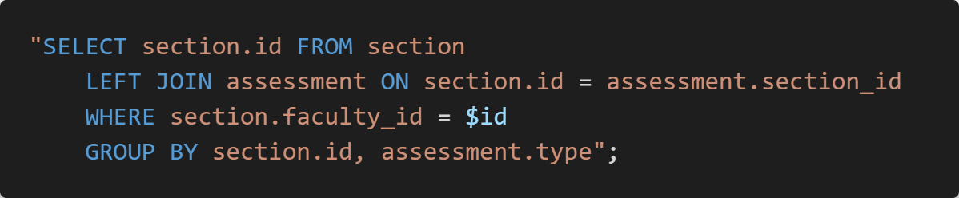

# **CHAPTER 5: CONCLUSION**

## **SECTION 5.1:PROBLEM & SOLUTION**

There are some problems that we have faced while creating the Student Performance Monitoring System (spms). The major issue was we had a lack of knowledge on the languages such as (PHP, CSS, JAVASCRIPT, HTML, SQL) that we must use while creating the system.

We came across this problem by seeking help from our faculty members through email or by doing problem solving sessions, who were experienced enough to guide us in creating the system.

We had issues using Github which was a new platform for us. So we tried doing some internet searches and gaining information ourselves and using it properly.

So, even though we did face some issues while creating the system, we learned to fix it too. We took a long time to learn the languages and we divided in our group individually and discussed all together on which part we do and then worked together in the coding part. We manually check each line for the coding to make sure to find the error and fix it.

## **SECTION 5.2: FEATURES & FUTURE DEVELOPMENT**

Further development that we will be working on is getting to receive a large amount of data to work on.in future we will try to add more features.

* The addition of A question Bank page where faculty can upload their question and collect the previous question paper from there.
* An addition of an automated result page where students can see their result after a semester ends.

## **SECTION 5.3: CONCLUSION & RECOMMENDATION**

This Student Performance Monitoring System would provide an insight about how learning might improve in a given program. We have created a SPMS, a system through which a user can take inputs and outputs. We have tried to design, build and tried to implement the best quality for our SPM system. We believe this system will help the Department members and faculty to save much more time to work on and improve the quality of education. This system allows the user to Collect the resources they need and can store all the available information and analysis. We believe this system will help the faculty member to keep track of their student performance and also will help to improve their performance.

# **Contribution of Each Member**

|  | Md.Abubakkar Siddik | Adnan Rahman Sharon | Md.Ashikur Rahman | Saif Islam Anik | Shahadatul Islam | |  |
| --- | --- | --- | --- | --- | --- | --- | --- |
| Cover Page |  | ✔ |  |  | |  | |
| Table of Contents | ✔ |  |  |  | |  | |
| Background of the Project |  |  | ✔ |  | |  | |
| Objectives of the Project |  |  |  |  | | ✔ | |
| Scope of the Project |  |  |  | ✔ | |  | |
| Existing Rich Picture | ✔ |  | ✔ |  | |  | |
| Existing Six Element System Analysis | ✔ |  | ✔ |  | |  | |
| Existing BPMN | ✔ |  | ✔ |  | |  | |
| Existing Problems and Analysis of the Problems | ✔ |  | ✔ |  | |  | |
| Proposed Rich Picture |  | ✔ |  | ✔ | | ✔ | |
| Proposed Six Element System Analysis |  | ✔ |  | ✔ | | ✔ | |
| Proposed BPMN |  | ✔ |  | ✔ | | ✔ | |
| Business Rules |  |  | ✔ |  | |  | |
| ERD | ✔ |  |  |  | | ✔ | |
| Relational Schema |  | ✔ |  | ✔ | |  | |
| Normalization | ✔ | ✔ |  |  | | ✔ | |
| Data Dictionary |  |  | ✔ | ✔ | |  | |
| Input Forms – Related SQL Used | ✔ | ✔ | ✔ | ✔ | | ✔ | |
| Output Query and Reports – Description along with SQL | ✔ | ✔ | ✔ | ✔ | | ✔ | |
| Input forms and output reports | ✔ |  |  |  | |  | |
| System Design | ✔ | ✔ |  |  | |  | |
| Problem & Solution | ✔ | ✔ | ✔ | ✔ | | ✔ | |
| Feature and Future development |  | ✔ | ✔ | ✔ | | ✔ | |
| Conclusion and Recommendation |  |  | ✔ | ✔ | | ✔ | |